HA NOI UNIVERSITY OF SCIENCE AND TECHNOLOGY

**SCHOOL OF ELECTRONIC AND TELECOMMUNICATION**



**REPORT**

**MICROPROCESSOR PROJECT**

1. **TOPIC: Air Quality Measurement System**

**Intructor: M.r Han Huy Dung**

**Group 4**

**Member:**

**1: Nguyễn Tuấn Anh ID: 20150127**

**2: Nguyễn Thành Đô ID: 20150952**

**3: Nguyễn Hữu Triệu ID: 20153916**

**4: Lại Huy Minh ID: 20152440**

Hà Nội 6-2017

Hà Nội 6-2017

Evaluation report (các nhóm tự đánh giá báo cáo của mình và tự cho điểm)

***Very poor (1); Poor (2); Achieve (3); Good (4); Excellent (5)***

|  |  |  |  |  |  |  |
| --- | --- | --- | --- | --- | --- | --- |
| **Combination of theory and practice (20)** | | | | | | |
| 1 | Indicate the urgency and importance of the subjects, issues and hypotheses (including purpose and appropriateness) as well as the scope of application of the project. |  |  |  | 4 |  |
| 2 | Functional / non-functional requirements are clearly defined (at least 10 non-functional requirements.) Relevant standards (Vietnam, International) |  |  |  | 4 |  |
| 3 | Updated research results, latest market information (domestic / international) |  |  |  | 4 |  |
| 4 | Specify the research method / solution  (block diagrams, algorithm flow, code types) |  |  |  |  | 5 |
| 5 | Simulated results and clear results achieved |  |  |  | 4 |  |
| 6 | Experimental results and clear results achieved |  |  |  | 4 |  |
| 7 | Using manuals |  |  | 3 |  |  |
| **Ability to analyze and evaluate the results (15)** | | | | | | |
| 8 | Clearly work plan includes objectives and methods of implementation based on the results of theoretical systematic research findings |  |  |  |  | 5 |
| 9 | In the results and conclusions, the author specifies the difference (if any) between the results obtained and the initial objectives and provides arguments for the proposed solutions can be done in the future |  |  | 3 |  |  |
| **Writing skills (10)** | | | | | | |
| 10 | The report presents a prescribed form with the program logic structure and beautiful, with the opening chapters and conclusions chapter |  |  |  |  | 5 |
| 11 | There are tables, clearly images, title, be numbered automatically and are explained and mentioned in the report, there is alignment, spacing after punctuation, commas etc. |  |  |  |  | 5 |
| 12 | Reference lists and cited regulations |  |  |  |  | 5 |
| 13 | Excellent writing skills (sentence structure standard (with subject, predicate), scientific style, logic and basis, appropriate vocabulary etc.) |  |  |  | 4 |  |
| **Total score** | | **55/65** | | | | |

**Comments by the marker:**

**Comments by the marker:**

CONTENTS

List of figures 5

List of tables 6

CHƯƠNG 1 Topic Overview 7

1.1 Introduction 7

1.2 Ideals, needs 7

1.2.1 Ideal 7

1.2.2 Needs 7

1.3 Objectives 7

1.4 Similar product in the market 8

1.4.1 Air Quality Particle Counting Meter PCE-RCM 10 8

1.4.2 Air Quality Temperature Humidity Meter PCE-HT110 8

1.4.3 Comment 9

1.5 Conclusion 9

CHƯƠNG 2 Analysis and Design 10

2.1 Functional and non-functional requirements of the system 10

2.1.1 Functional requirements: 10

2.1.2 Non-functional requirements: 10

2.2 Block Diagram 11

2.3 Design each block 13

2.3.1 Microcontroller: 13

2.3.2 Sensor: 13

2.3.2 Display LCD 14

2.3.4 Wifi module 14

2.4 Implementation Plan 14

2.5 Conclusion 15

CHƯƠNG 3 Important Knowledge 16

3.1 Microcontroller 16

3.2 LCD Screen 16x2 17

3.3 Humility and temperature sensor 20

3.2 Module Wifi 21

3.3 Code Tools 22

3.4 Simulation Tools 23

3.5 Circuit Drawing Tools (Reasons and Introduction to Tools) 23

3.6 Conclusion 23

CHƯƠNG 4 Implementation 24

4.1 Algorithm flowchart 24

4.1.1 LCD 16*2 24

4.1.2 Sensor block 25

4.1.2.1 Humility and temperature sensor 25

4.1.2.2 Dust sensor 26

4.1.2.3 Module wifi 27

4.2 Relationship between software and hardware blocks 27

4.3 Sequence diagram, state machine. 27

4.4 Code structure 29

4.4.1 LCD library 29

4.4.2 DHT11 library 29

4.4.3 ADC library 29

4.4.4 UART library 30

4.4.5 Main program 30

4.5 Print circuit 31

4.6 Conclusion 32

CHƯƠNG 5 Testing and Evaluation 33

5.1 Software part test on simulation system 33

5.2 Hardware part test (with software included) 33

5.2 Overall hardware test 34

5.4 Evaluation 34

5.5 Conclusion 34

CHƯƠNG 6 Conclusion and Development 36

6.1 Summary achievements and existing issues 36

6.2 Lessons Learned 36

6.3 Direction of development 36

References 43

List of figures

Figure 1. 1 Image of PCE-RCM 10 8

Figure 1. 2 Image of PCE-HT110 9

Figure 2. 1 Block diagram 12

Figure 2. 2 PIC16F877A 13

Figure 2. 3 DHT11 13

Figure 2. 4 PSM7003 13

Figure 2. 5 LCD 16x2 14

Figure 2. 6 Module wifi esp8266 14

Figure 3. 1 Port diagram of PIC 16F877A 16

Figure 3. 2 Image of LCD 16*2 17

Figure 3. 3 Image of DHT11 sensor 20

Figure 3. 4 Diagram ports of sensor DHT11 21

Figure 3. 5 Image of module wifi ESP8266 21

Figure 4. 1 LCD 16*2 flowchart 24

Figure 4. 2 Sensor DHT11 flowchart 25

Figure 4. 3 PMS 7003 flowchart 26

Figure 4. 4 Module wifi ESP8266 flowchart 27

Figure 4. 5 Sequence diagram in Altium 28

Figure 4. 6 PCB diagram 31

Figure 4. 7 PCB 3D view (front) 32

Figure 4. 8 PCB 3D view (back) 32

Figure 5. 1 Simulation by proteus 34

Figure 5. 2 Test on the breadboard 34

Figure 5. 3 The complete Circuit 35

List of tables

Table 2. 1 Table assignment works 15

Table 3. 1 LCD ports table 19

Table 3. 2 Characteristic of sensor DHT11 20

Table 4. 1 Sequence diagram of the circuit 29

1. Topic Overview

1.1 Introduction

Air is the most important part of our life. Air always exists around us, provides Oxygen to maintain this life. Nowadays, its quality becomes bad in the most counties. There are many problems about the air such as the global warming, the concentration of CO2, SO2, the increasing of dust density, et. So, the importance of measuring quality of the air is very high. If we could know clearly about the quality of the air, it will help us to prepare ways to adjust and to improve our life.

1.2 Ideals, needs

1.2.1 Ideal

The ideal of my circuit starts from the necessary of many people who want to know about the air around them. We understand that there are many things we can do if we know about air quality. With the roles of an engineer in the future, combine to the knowledge that we have learned in this course, we realize that we can make a circuit to solve the problem above.

1.2.2 Needs

The needs of the air quality measurement circuit appear in many fields, careers in the real life:

With farmer, they need to know about temperature or humidity to decide the ways to take care of their trees or their animals.

With doctors, they need to know about the dust density, temperature to decide or adjust the direction of cure the patient.

With the engineers, they need to know about the temperature to protect the components because there are many things which can be affected by temperature.

With three examples above, we can see that our ideal is very important and it has many application, specially it is very useful to the people who work the job that have relationship with the air.

1.3 Objectives

Our purpose when choosing the project is using the microcontroller communicates with the temperature sensor, humidity signaling information to the user:

Design and make a circuit that can measure at least three elements. Apply all the knowledge that we learned in this course. Improve the knowledge about the object microprocessor, the soft skill as English, teamwork, communication. And understand clearly about the work of engineer, then direct the work in the future.

1.4 Similar product in the market

Now, there are many products that have similar purpose with us.

1.4.1 [Air Quality Particle Counting Meter PCE-RCM 10](https://www.pce-instruments.com/english/measuring-instruments/test-meters/air-quality-meter-air-quality-particle-counting-meter-pce-rcm-10-det_5850060.htm?_list=kat&_listpos=1)

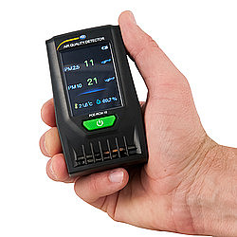

Figure 1. 1 Image of PCE-RCM 10

PCE-RCM 10 is a portable handheld air quality particle counting meter or particle counter used to monitor particulate matter (PM) concentrations in the air. Designed to aid in indoor air quality (IAQ) assessments, this particle counter also measures air temperature and relative humidity (RH).

When inhaled, PM 2.5 and PM 10 particles can settle deep into the lungs and result in damaging health effects. Since the PCE-RCM 10 particle counter monitors PM 2.5 and PM 10 particles, the device has many practical health and safety applications. Heating, ventilation and air conditioning (HVAC) technicians use PM 2.5 and PM 10 particle counters for HVAC system performance and filtration audits. In addition, industrial hygienists and workplace safety professionals rely on PM 2.5 and PM 10 particle counters when evaluating occupational health and safety risks related to hazardous and combustible dust.

1.4.2 [Air Quality Temperature Humidity Meter PCE-HT110](https://www.pce-instruments.com/english/measuring-instruments/test-meters/air-quality-meter-air-quality-temperature-humidity-meter-pce-ht110-det_1541004.htm?_list=kat&_listpos=2)

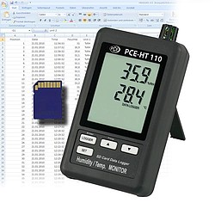

Figure 1. 2 Image of PCE-HT110

The PCE-HT110 Air Quality Meter or Humidity Detector precisely measures air temperature and relative humidity. This accurate and reliable device shows the current measurements on the large LCD display and saves the measurement data directly to an SD card (included). The PCE-HT110 is equipped with two channels, accommodates an SD card memory of up to 16 GB, offers an adjustable measurement rate / sampling interval, and includes a wall mount, making the device ideal for logging data over an extended period of time.

Measurement ranges: **0 … 50°C / 32 ... 122°F, 10 ... 90% RH**  
Resolution: 0.1°C / 0.18°F, 0.1% RH  
Data format: .XLS (compatible with Microsoft Excel).

1.4.3 Comment

In general, the products above is quite good. However, they have a weakness that they only measure one or two elements are temperature or humidity or both. So, our circuit will be the best choice compare them.

1.5 Conclusion

So, by our confidence, we believe that our circuit will be suitable with the requirements of this object. While doing this project, we tried to limit any mistake, but because of limitation about major knowledge, our product steadily has many problems. We hope everyone could evaluate and offer a suggestion to perfect it.

We want to give our gratefulness to Mr. Han Huy Dung because of the knowledge that he taught in the class, his enthusiasm helped us very much in the process doing this project.

1. Analysis and Design

2.1 Functional and non-functional requirements of the system

From ideas, needs, and similar products in practice, our team offers functional and non-functional requirements for the product as follows:

2.1.1 Functional requirements

Device has temperature, humidity (DHT11) and dust sensors (PM2.5 GP2Y1010AU0F). Microcontroller (PIC 16F877A) sends values to LCD and also sends to server using ESP8286 Wifi module (TCP/IP) every 30 minutes (using terminal to simulate server)

When the dust index exceeds the standard value, turn on the motor (to turn on the fan)

Device has LCD which displays sensor values based on the following modes: Only temperature, only humidity, only dust index, all parameters.

Circuit also has one LED to notify power supply and another LED to notify when microcontroller get the values from the sensors

2.1.2 Non-functional requirements

Sensor working properly in conditions with the temperature from 5 to 60 degree Celsius, the humidity =< 80% RH and the dust density value from 0 to 500 ug/m3.

* The speed approach 10MHz at 3.7-4V; 20MHz at 4-5V
* The circuit uses the power supply has the value 9(V) using a Lithium battery
* The shape is rectangular, it is quietly weight and the dimensions is about 150x150x50mm
* We use LCD 16x2 to display the value of measurements
* Connection we use Jack DC: 5.5x2.5mm.
* The time to market of product is 8 weeks.
* In real conditions in Vietnam if being well-preserved, the product can be used for more than 12 months
* The cost is roughly 700 000VND

2.2 Block Diagram

The device has a temperature sensor, air humidity, dust quality and signaling LEDs. The microcontroller displays information and sends it to the server using the ESP8286 (TCP / IP) wifi module once every 30 minutes (using the terminal to simulate the server). When the temperature is too low, the light will turn on to provide heat to keep the plant warm. When the soil moisture exceeds certain thresholds, the device automatically turns on the mini motor to pump water. The device has a keyboard and an LCD display to display the sensor values.

The block diagram of the system is as follows:

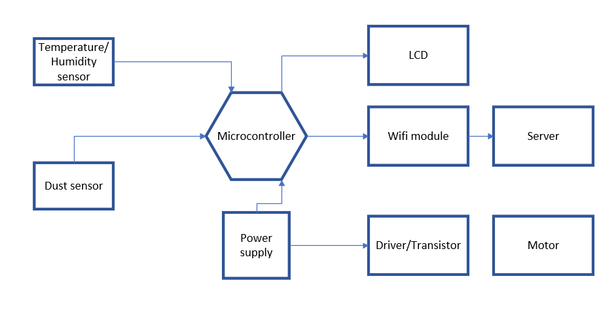

Figure 2. 1 Block diagram

By analysis the system diagram we have more important information that is showed below:

Power supply: Use 5V / 2A adapter to power the circuit. Particularly the communication block needs to use 3.3V from IC lm7833.

Processor block - controller: using the 16F877A PIC microcontroller. When the microcontroller pic 16F877A receives information about the temperature, humidity of the environment from the DHT11 sensor, dust quality from the PMS7003 sensor sent back, the microcontroller will display that information through the display block also sends information about the server through the communication block. The block receives the signal from the keypad for display.

Sensor block: use the temperature sensor, DHT11 air humidity and PMS7003 dust sensor to measure and send information about the microcontroller.

Keypad control block: Provides signal to the processor block.

Display block: displays the temperature, humidity values ​​of the environment measured by the sensors.

Communication Unit: use the wifi module to transmit and receive information about the temperature and humidity of the environment to the monitoring server.

* 1. Design each block

2.3.1 Microcontroller:

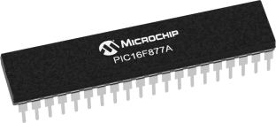

Figure 2. 2 PIC16F877A

With PIC 16F877A, we use two registers for input and output management: TRIS is the directional register, when TRIS = 1 is INPUT while TRIS = 0 is OUTPUT. PORT is the data register, when TRIS = 0, the signal is output while TRIS = 1 receives the data.

2.3.2 Sensor:

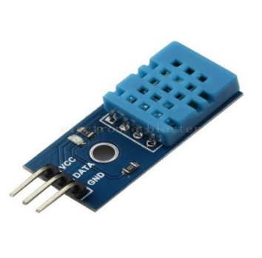

Figure 2. 3 DHT11

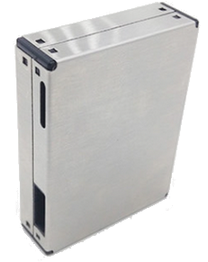

Figure 2. 4 PSM7003

We use DHT11 to measure the temperature and humidity simultaneously.

For dust sensor, we use module PSM7003 to measure dust quality.

2.3.2 Display LCD

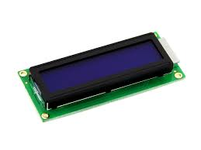

Figure 2. 5 LCD 16x2

LCD will be used by easy visibility, flexibility in display information, design circuit will be simpler. The display block is displayed when the external button is pressed (all information is displayed in one turn).

2.3 Wifi module

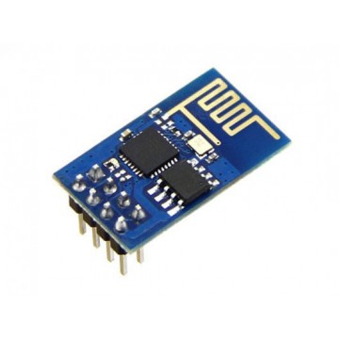

Figure 2. 6 Module wifi esp8266

In this case we use esp8266 wifi module. The ESP8266 is a SOC module with a 32-bit, TCP / IP-based processor that can store applications or process WiFi connections from the on-chip processor, making it possible to connect like a host or bridge.

2.4 Implementation Plan

|  |  |  |
| --- | --- | --- |
| Week | Work | Human source |
| 5 | Install software, assign team leader, learn subject | All member |
| 6 | Implement the GPIO interface code, flashing the LED | Huu Trieu |
| 7 | Make the display on the LCD screen | Nguyen Tuan Anh |
| 8 | Read data from air humidity sensor and air temperature | Thanh Do |
| 9-10 | Read dust sensor data | Huy Minh |
| 10 | Communication, transmitting data read from the sensor via the ESP 8266 wireless module | Tuan Anh |
| 11-12 | Simulation, drawing the principle diagram | Huu Trieu |
| 14-16 | Draw a printed circuit | Tuan Anh |
| 17 | Complete the product | Tuan Anh |
| 18 | Complete report | Minh, Do, Trieu |

Table 2. 1 Table assignment works

This table describes the works of each member have to complete in all progess doing this project. The work that is assigned are suitable with the abillity of each member, it will help the work can do faster.

2.5 Conclusion

Through chapter 2, group 6 has come up with the idea, analysis and design of the basic system to meet the requirements.

1. Important Knowledge
   1. Microcontroller

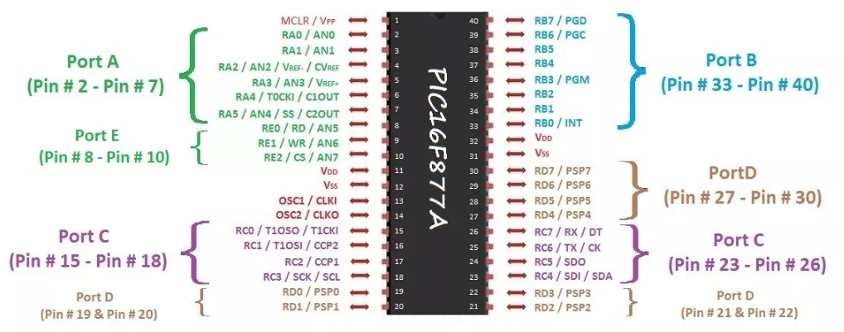

Figure 3. 1 Port diagram of PIC 16F877A

Here are some parameters and characteristics of pic 16f877a:

The program memory: 8K x 14bit and the data memory: 368 x 8byte RAM and 256 x 8byte EEPROM. There are five ports A, B, C, D, E with many different function ways. The operating voltage from 2.5 - 5.5V and the maximum operating frequency 20Mhz.

Three timer normally use: Timer 0: 8-bit counter with frequency divider. Timer 1: 16-bit counter with frequency divider, can perform counting function based on peripheral clock as soon as microcontroller operates in sleep mode.

3.2 LCD Screen 16x2

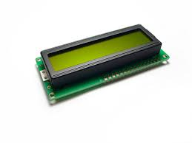

Figure 3. 2 Image of LCD 16*2

Here are some parameters and characteristics of LCD 16x2:

|  |  |  |
| --- | --- | --- |
| Port | Name | Meaning |
| 1 | VSS | Connect to ground LCD, when design connect port GND of microcontroller |
| 2 | VDD | Port supply source for LCD, this port connects with VCC 5v |
| 3 | VEE | Control display LCD |
| 4 | RS | Resistor selects  RS connection with logic  “0” (GND) or logic “1” (VCC) to select registers.  Logic “0”: Bus DB0-DB7 will connect to the command register IR of  LCD (write-write mode) or connected to the address’s counter  LCD (read-read).  Logic “1”: Bus DB0-DB7 will be connected to the side data register  in the LCD. |
| 5 | R/W | Read / Write mode selector. Connect R / W with  logic “0” so that LCD operates in write mode, or connected to logic “1”  Leave LCD in read mode. |
| 6 | E | Enable. After the signal is placed on the bus  DB0-DB7, commands are only accepted when a pulse is given  spell of foot E.  + In recording mode: The data on the bus will be transferred to the LCD (accept  Recipes inside it when detecting a high-tolow transition of the footprint E.  + In reading mode: Data will be output to LCD DB0-DB7 when  low-to-high transition at the E leg  LCD keeps on the bus until the foot E drops to low |
| 7-14 | DB0-DB7 | Eight data bus lines are used to exchange information with  MPU. There are two modes that use these eight buses:  + 8 bits mode: Data is transmitted on all 8 lines, with bit  MSB is DB7 bit.  + 4 bits mode: Data is transmitted on 4 lines from DB4 to  DB7, MSB bit is DB7 |
| 15 | - | Positive for backlight |
| 16 | - | GND for backlight |

Table 3. 1 LCD ports table

This table show us all the name and the function of LCD ports. This will help us code or design with LCD easily.

3.3 Humility and temperature sensor

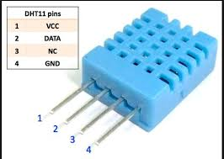

Figure 3. 3 Image of DHT11 sensor

DHT11 Temperature sensor, humidity is very popular now because of cost cheap and easy to get data through 1-wire communication (1-wire digital communication unique data transfer).

* Characteristics of the sensor DHT11

|  |  |
| --- | --- |
| source | 3-5v DC |
| humidity | 20% to 90 % |
| temperature | 0 -50C |
| frequency | 1Hz |
| distance | 20m |

Table 3. 2 Characteristic of sensor DHT11

* Principles of operation of DHT11:

To be able to communicate with the DHT11 standard 1-pin microprocessor follow 2 steps: Send the wanted signal to the DHT11, then confirm the DHT11. When communicating with DHT11, the sensor sends back 5 bytes of data and measured temperature

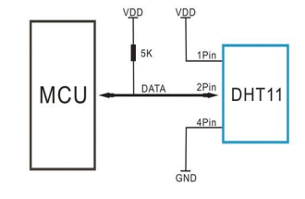

Figure 3. 4 Diagram ports of sensor DHT11

DHT11 sends and receives data with a DATA signal wires, with standard data 1 wire, we must ensure that in idle mode. The total market share of the temperature + 8 bits represents the decimal part of the temperature + 8 bits sum checksum.

DATA is high, so in the circuit using DHT11, the DATA line must is mounted with an external pull-out (normally the value is 4.7kΩ).

Data transmission of DHT11 consists of 40 bits of data in order: 8 bits of indication. Piece of moisture + 8 bits representing the decimal part of the moisture + 8 bit expression.

3.2 Module Wifi

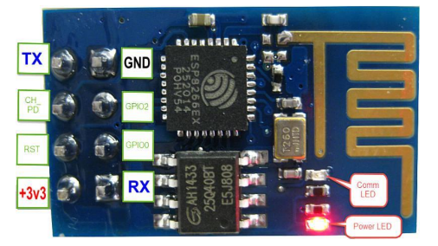

Figure 3. 5 Image of module wifi ESP8266

This is a simple Wifi transmission module based on the ESP8266 SoC chip. The ESP8266 is an integrated chip designed for the new connectivity standard. The circuit has a compact design, using UART interface.

It can be work when we supply 3.3VDC. The maximum current consumption can obtain 320mA. With wifi 2.4GHZ support for security standards such as: OPEN, WEB, WPA_PSK,… and UART interface with firmware support AT command set, the default Baurade 9600.

Pin Vcc is 3.3V the current can be up to 300mA so need separate source. GND connected to the ground. The Tx, Rx pin of the UART interface connected to the Tx, Rx pin of the microcontroller. The pin call CH-PD if pulled to high level will start wifi pickup, pull down low level module to stop the wifi broadcast. Because the ESP8266 starts to suck large current, we keep this pin at 0V when booting our system, after 2s pull this pin to 3.3V to ensure stable operation. Pin GPIO0 low down for firmware upgrade. We not used pin GPIO2.

3.3 Code Tools

The code engine uses the MPLAB X IDE software. This is a professional software programmer for microcontrollers with outstanding features such as:

Create programming environment C, ASM: XC8, embedded, CCS C Compiler, HTPIC C Compiler and other compilers. Debug and mix simulation program loader are used.

3.4 Simulation Tools

Simulation tool using Proteus software. This is a toolkit specializing in electronic circuit simulation. The software (tools) in the suite are: ISIS Schematic Capture.

Proteus is Labcenter Electronics' electronic circuit simulation software, which simulates most common electronic components, especially for MCUs such as PIC, 8051, AVR, and Motorola. Compared with other simulation software, Proteus has many outstanding advantages to select groups such as: Simulate many electronic components and display devices.

3.5 Circuit Drawing Tools (Reasons and Introduction to Tools)

The circuit drawing tool uses Altium Designer software. This is a drawing software commonly used today with the following advantages:

- Design interface, friendly management and editing, easy compilation, file management, version management for the Design document.

- Strong support for automatic design, automatic wiring optimization algorithm, component analysis. Supports finding solutions for designing or modifying circuit, components, netlist available in advance by new parameters.

- Open, view and print circuit design files easily with complete component information, netlist, drawing data, dimensions, quantities ...

- Place and edit objects on mechanical layers, define Design rules, customize the printed circuit layers, switch from schematic to PCB, place components on PCB

3.6 Conclusion

In this chapter, we summarize all the knowledge that we need to know if we want to understand the structure and the operational principle of this circuit. Then, we show all the tool that we used to simulate, draw the circuit and write code. All of them are important and they will help us in the other parts.

1. Implementation
   1. Algorithm flowchart

4.1.1 LCD 16*2

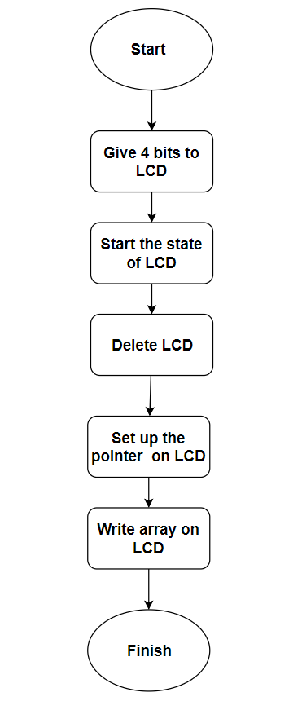

Figure 4. 1 LCD 16*2 flowchart

This chart describes the operational principle of LCD 16*2. This is divided into 7 steps. The previous step is linked with the follow step to do the function of LCD is showing information.

4.1.2 Sensor block

4.1.2.1 Humility and temperature sensor

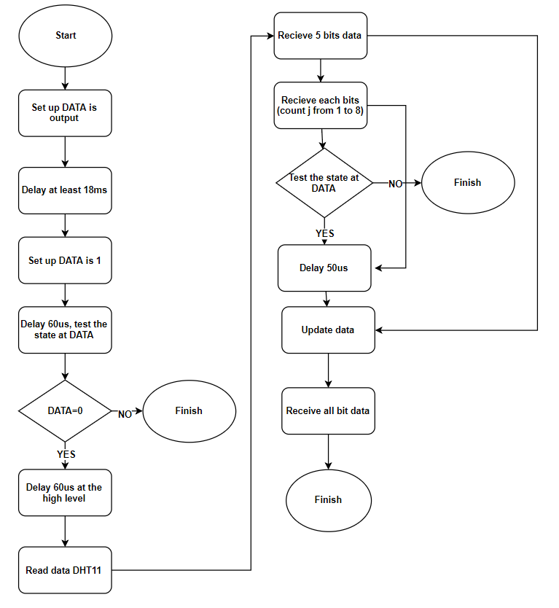

Figure 4. 2 Sensor DHT11 flowchart

Description: The algorithm flowchart base on the operational principle of DHT11 sensor

In order to interface with DHT11 in standard one-line microprocessor executes in 2 steps: Send a message that want to measure (Start) to DHT11, then wait until DHT11 confirm. When communicated with DHT11, sensor will send the 5 bytes data and temparature that be measured.

-Step 1: Send the start signal

+ MCU DATA set up DATA is Output, drag DATA to 0 in interval

time at least 18ms.

+ MCU given DATA up 1, after set up as input.

+ With the following data supervision, MCU can be known that if it is communicating with sensor or not. If a DCT11 change from 1 to 0 in

time defined, it completed the process MCU interface with DHT.

-Step 2: Read value on DHT11

DHT11 will return the value of temperature and humidity in 5 bytes. In which:

+ Byte 1: the integer part of humidity value (RH%)

+ Byte 2: the fractional part of humidity value (RH%)

+ Byte 3: the integer part of the temperature (TC) value

+ Byte 4: the fractional part of temperature value (TC)

+ Byte 5: Check the sum of byte 1, byte 2, byte 3, byte 4

4.1.2.2 Dust sensor

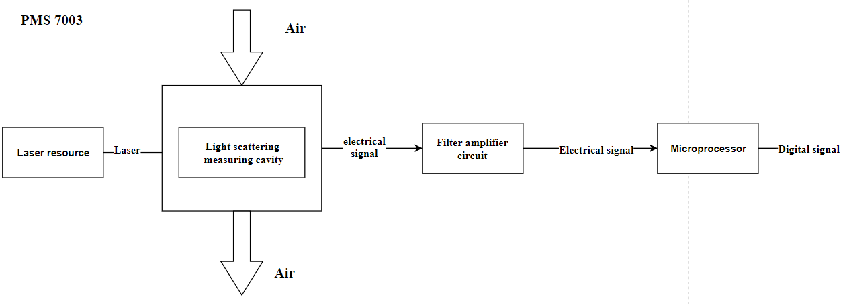

Figure 4. 3 PMS 7003 flowchart

This chart shows the operational principle of PMS 7003. First, it will shoot laser to the air, the electrical signal will be sent to filter circuit and microprocessor. Then, it will return a digital signal.

4.1.2.3 Module wifi

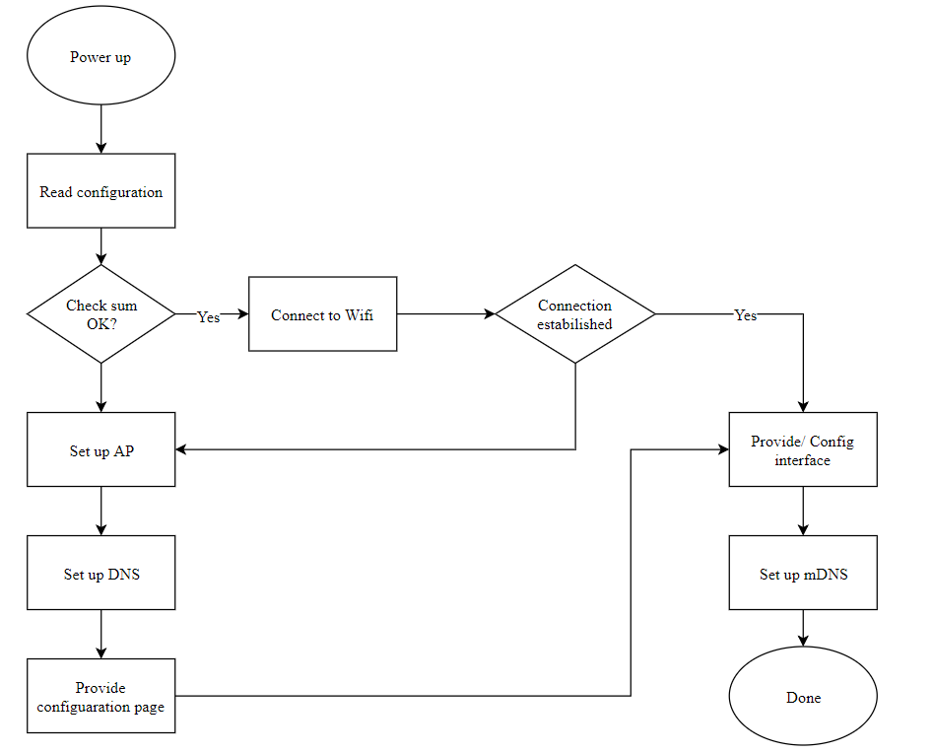

Figure 4. 4 Module wifi ESP8266 flowchart

This chart shows us the block diagram of module ESP8266. It is divided into many steps, provide us the overview about the way to set up the wifi connection in our circuit.

4.2 Relationship between software and hardware blocks

Microcontroller read the sensor type, control the status of LED and other devices. Using the friendly C programming language with microcontroller interface with ESP8266 for can be become a wireless network connection (no strings).

4.3 Sequence diagram, state machine.

Here is the sequence diagram that is written by Altium software. We divided it into 5 blocks, each block also has an important role.

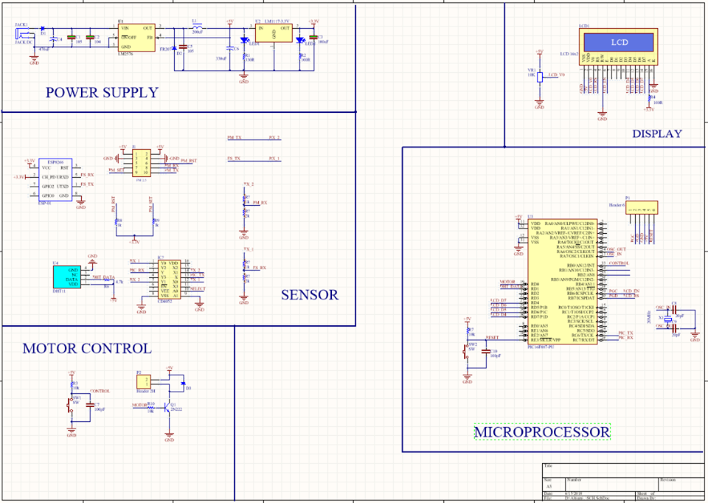

Figure 4. 5 Sequence diagram in Altium

|  |  |  |
| --- | --- | --- |
| Block | Main elements | Description |
| Power supply | LM 2576, LM1117 | Supply the activation power 5V for almost circuit, 3.3V for module Wifi |
| Sensor | DHT11, PMS7003, ESP8266 | Measure all the elements we need to know as temparature, humidity, dust. |
| Display | LCD 16*2 | Display the results measured by sensors. |
| Motor control | Motor |  |
| Microprocessor | PIC 16F877A | Control and handling the information. |

Table 4. 1 Sequence diagram of the circuit

This table shows us all the main elements in each block in the sequence diagram. It also has the clear description about their function.

4.4 Code structure

- Configuring the VCM, select the HS mode oscillator suitable for the frequency of the instrument. Set up the crystal frequency is 20MHz.

- Declare, include the library to use.

- Main program implementation system.

4.4.1 LCD library

* + - * File LCD.c:

Function definition:

- Void LCD_Send4Bit (unsigned char a): Move to 4 bits up LCD.

- Void LCD_Send_Command (command char unsigned): Command write divide fuction into 4 bits hight to 4 bits low in character in the defined encoding the given column (4 bits high), row (4 bits low).

- Void LCD_Init (void): Initialize initial for LCD.

- Void LCD_PutString (char * s): Write 1 string to LCD.

* + - * File LCD.h:

Including header of LCD functions above.

4.4.2 DHT11 library

* File DHT11.c:

Function definition:

- Unsigned char DHT_GetTemHumi (unsigned char * tem, unsigned char * humi): get information of temparature and humidity from sensor DHT11, include 2 sections: One is set to perform the transaction and check signal from microcontroller sent the sensor and signal from the sensor response microcontroller to. Two is read the sensor data.

* File DHT11.h:

Including header of the above functions.

4.4.3 ADC library

* + - * File ADC.c:

Function definition:

- Void ADCinit (void): Generate ADC, select frequency, select channel, configuration

port.

- Unsigned int ReadADC (void): Function reading ADC conversion value.

* File ADC.h:

Including header of the functions above.

4.4.4 UART library

* File UART.c:

Function definition:

- Char UART_Init (const long int baudrate): Initialize UART: initialize

create baudrate value.

- Void UART_Write_Text (char * text): Write 1 paragraph text to display

computer.

* File UART.h:

Including header of the functions above.

4.4.5 Main program

Main.c: is where contains the main directory void (void) program run all the programs include: the interrupt, the sensor of the temperature, humidity, display on LCD, send data through wife, interface with computer… The program runs continuously.

4.5 Print circuit

Here is the circuit layout that we were designing on Altium software:

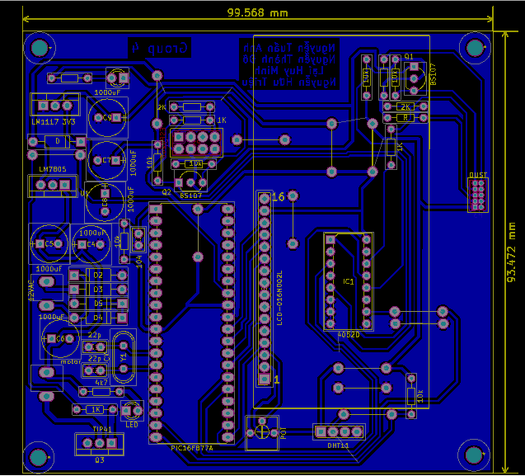

Figure 4. 6 PCB diagram

PCB will show the way of wire and the position of elements in the real circuit. Writing PCB is the important step, a nice PCB can help us make circuit easily.

Figure 4.7 shows the 3D view at the top of the circuit

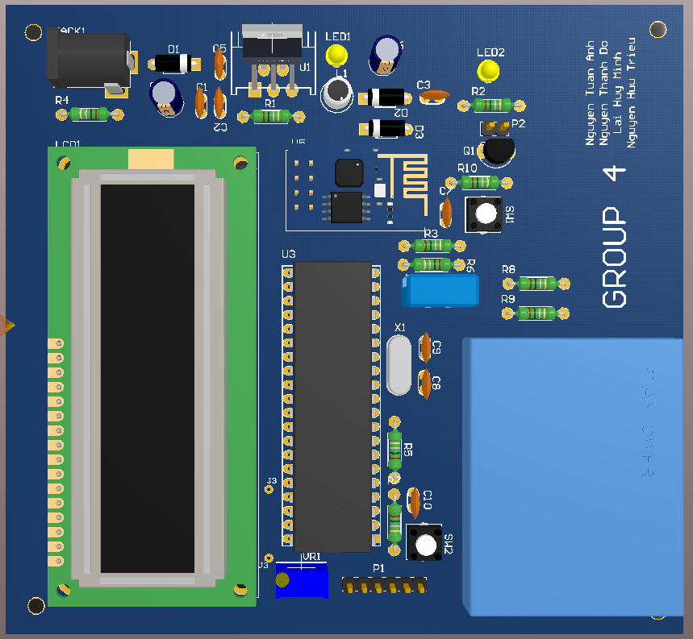

Figure 4. 7 PCB 3D view (front)

Figure 4.8 shows the 3D view at the bottom of the circuit

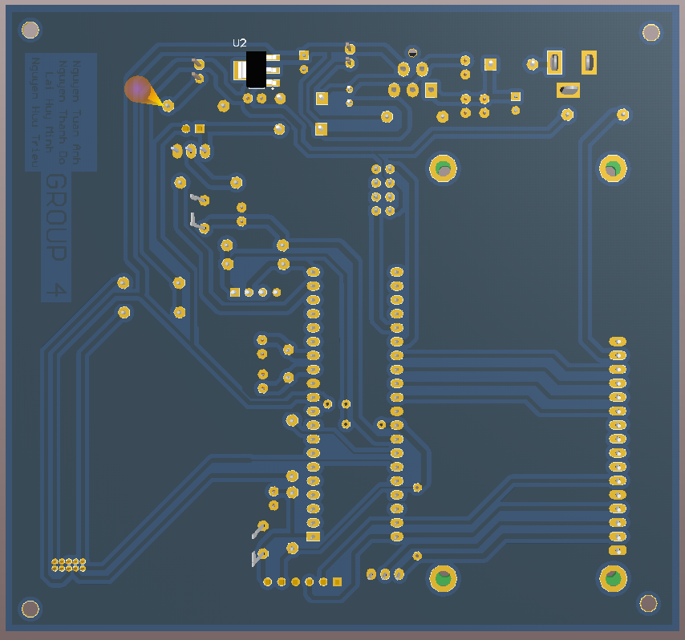

Figure 4. 8 PCB 3D view (back)

4.6 Conclusion

In this chapter, we show you the flowchart of LCD and sensor DHT11 to help you know about the way they operate. Then, it is the code structure and the picture of the print circuit. This is the most important part because it has all the knowledge that we learned to complete this project.

1. Testing and Evaluation
   1. Software part test on simulation system

Figure 5.1 shows the process of testing the circuit in proteus software

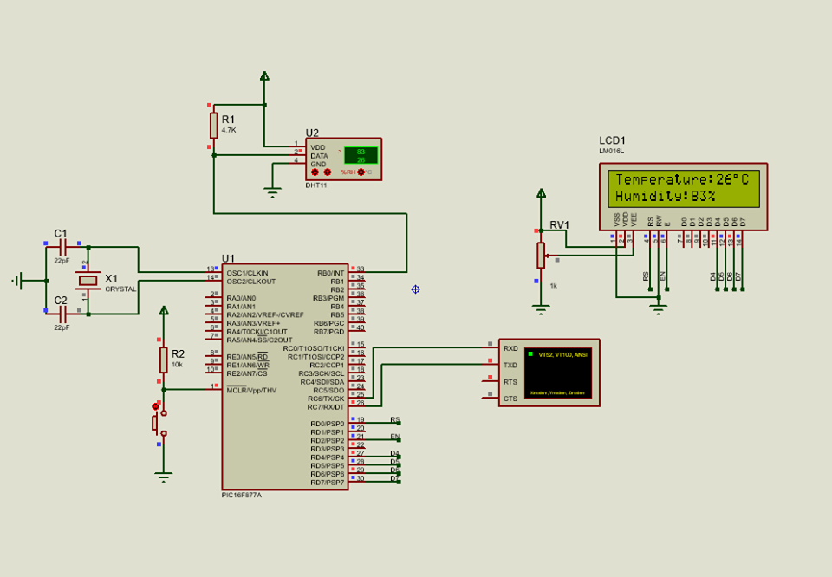

Figure 5. 1 Simulation by proteus

This is the schematic circuit that written by Proteus. We simulated the circuit before do it. In this figure, we can see that the circuit operated normally.

* 1. Hardware part test (with software included)

After testing in proteus, we were working on breadboard as showing in Figure 5.2

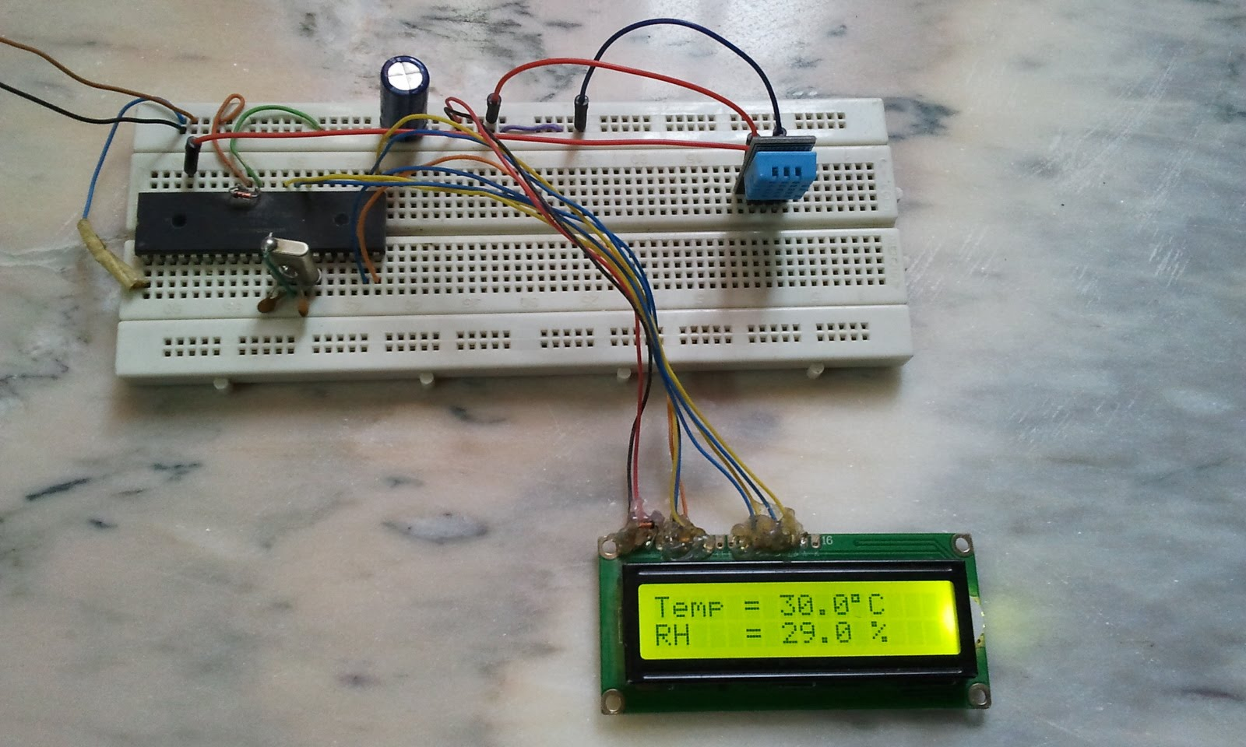

Figure 5. 2 Test on the breadboard

Testing in the breadboard will help us know about the mistake we can meet and the stabilization when we active the circuit.

* 1. Overall hardware test

Testing the real circuit is shown in figure 5.3

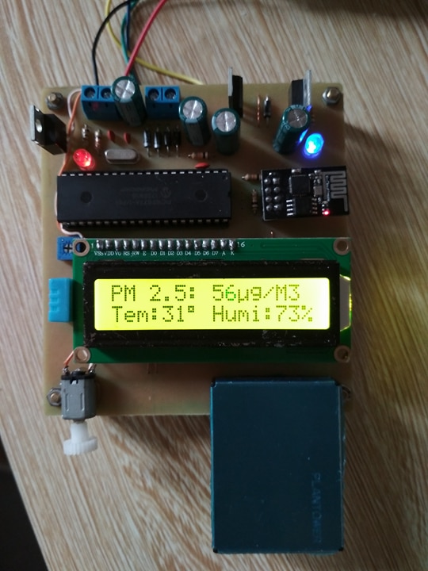

***Figure 5. 3 The complete Circuit***

This figure shows the completed circuit. We can see that it operates normally, and response every requirement of this project.

5.4 Evaluation

Through the tests each block and overall in terms of software as well hard, basic product circuit has been operating properly set out, small circuit.

neat.

5.5 Conclusion

This chapter show you everything about simulation or testing. Then, we evaluated and compared the result between simulation and testing. From that, we can adjust or alter about our circuit as parameters, devices to reach the beginning desires.

1. Conclusion and Development

6.1 Summary achievements and existing issues

Simulation circuit and real circuit has response the requirements of the project: measure at least 3 elements, apply all knowledge about sensor, microprocessor, LCD… that have studied.

All the members helped each other, contribute the ideals to complete and develop the project.

All members understand more deeply about structure, operational principle, functions and applications of microprocessor PIC16F877A. Since that, we could complete the knowledge that we have learned in the class.

Increasing the ability about code C, C++, using MC office, presentation, reading and understanding the English references.

Achieve some experiences to make real circuit.

6.2 Lessons Learned

The circuit need more accuracy, aesthetics and have more applications. The code ability is not good. Working progress is quite slow. The level of each member is not equal.

6.3 Direction of development

Use more than may like the wind speed sensor, PH sensor, light sensor... to provide enough information for user. Build a server to save and update data. Design web app to access and display data. Extend the system to hardware network.

**Note A:** Contribution of each individual

A.1 Contribution of Nguyễn Tuấn Anh

- Design schematic diagram of the circuit.

- Layout PCB on Altium designer.

- Code for LCD, DHT 11, Dust sensor.

- Testing for real circuit.

A.2 Contribution of Lại Huy Minh

- Buy some components of the circuit

- Contribution about finance to the group

- Edit for Chapter 1- Topic Overview of the report

- Edit for Chapter 6- Conclusion and Development of the report

- Edit for Chapter 4- Implementation of the report

- Testing the circuit on breadboard

- Draw flowchart algorithm for DHT 11, LCD

- Testing some block on proteus

A.3 Contribution of Nguyễn Thành Đô

- Create specification of the system.

- Build the overall diagram of the circuit.

- Buy some components of the circuit.

- Contribution about finance to the group.

- Edit for Chapter 2- Analysis and Design of the report.

- Edit for Chapter 5- Testing and Evaluation of the report.

- Check for error of the real circuit.

A.4 Contribution of Nguyễn Hữu Triệu

- Edit for Chapter 3- Important knowledge of the report.

- Buy some components of the circuit.

- Contribution about finance to the group.

- Support to make real PCB.

- Draw holes on the circuit.

- Soldering components.

- Drawing flow chart for each block.

**Note B. Source code**

#include "VXL_GROUP4.h"

#include "lcd.h"

#include "TA_DHT11.h"

#include "TA_Uart.h"

LCD lcd = { &PORTD, 3, 2, 4, 5, 6, 7 }; // PORT, RS, EN, D4, D5, D6, D7

void __delay_timer0_ms(unsigned int t)

{

while(t--)

{

// Delay 1 ms

TMR0 = 100;

TMR0IF = 0;

while(!TMR0IF);

}

}

void __delay_timer0_Init()

{

T0CS = 0; // Choose internal clock source

PSA = 0; // Bo chia duoc su dung cho Timer0

PS2 = 1; // Pre scale = 1:32

PS1 = 0;

PS0 = 0;

}

//********************END DELAY***********************************************//

unsigned char RX_Buffer[32];

unsigned int Dust=0;

char Receive_Value()

{

for(int i=0;i<32;i++)

{

while(!Uart_Data_Ready());

RX_Buffer[i]=Uart_Get_Char();

}

return 1;

}

void main()

{

__delay_timer0_Init();

unsigned char str1[16];

unsigned char str2[16];

unsigned char dht_temper=10,dht_humid=20;

Uart_Init();

TRISD0=0;

TRISB0=0;

RD0=1;

LCD_Init(lcd);

LCD_Clear();

while(1)

{

if(Receive_Value())

{

LCD_Set_Cursor(0,0);

Dust = RX_Buffer[12]*256 + RX_Buffer[13];

sprintf(str2,"PM 2.5: %u",Dust);

LCD_puts(str2);

LCD_putc(0xE4);

LCD_puts("g/M3");

if(Dust>=100)

RB0=1;

if(Dust<100)

RB0=0;

}

if(dht11_measure(&dht_temper,&dht_humid))

{

LCD_Set_Cursor(1,0);

sprintf(str1,"Tem:%u",dht_temper);

LCD_puts(str1);LCD_putc(223);

LCD_Set_Cursor(1,8);

sprintf(str1,"Humi:%u",dht_humid);

LCD_puts(str1);LCD_putc('%');

}

}

}

**Note C. User Manual**

The circuit must be supplied with voltage from 7V to 45V in order to guarantee that the output voltage is constant 5V DC. The current that was used is big enough so that it can draw the esp8286 well in many circumstances. Keep it drained and mossy, keep it away from children. If there is dust on the surface use drained rags to clean it. The data was collected continuously so that the wifi connection should stay stable in order to ensure that no distortion occurs

**Note D.** Statistics on test results

**Note E. Some acknowledgement**

* Altium layout skill
* Proteus Simulation
* Making real PCB
* Know about some basic knowledge of microprocessor
* Know about some basic knowledge of measurement and sensor
* Know how to use C language and use MPLAB software to implement that code for pic16f877a
* Know how to read datasheet of each components

References

1. DHT11- temparature and humidity sensor <https://components101.com/dht11-temperature-sensor>
2. Espressif IOT Team <https://www.espressif.com/sites/default/files/documentation/0a-esp8266ex_datasheet_en.pdf>
3. Zhou Yong file:///F:/New%20folder/2017-20182/microprocessor/code/PMS7003_datasheet.pdf
4. 2003 Microchip Technology Inc. <https://drive.google.com/drive/folders/1Na6SeB7gWWs_aiyLEzNL2pbgR1n2jbac>
5. <https://www.engineersgarage.com/electronic-components/16x2-lcd-module-datasheet>